|  |  |
| --- | --- |
| EGC_Black | **MATHEMATICS:SPECIALIST**  **VALIDATION ON ASSIGNMENT**  **SEMESTER TWO 2019**  **Calculator Free** |

Time Allowed: 15 minutes Total Marks: 15

Question 1 (7 marks)

(a) Solve the equation $\tan\left(\frac{x+25°}{2}\right)=\sqrt{\frac{}{}tatt3}$ $\tan\left(\frac{x+25}{2}\right)=\frac{1}{\sqrt{3}}$ for $0°≤x≤540°$. (3 marks)

(b) Prove that $\left(1-\cos{x}\right)\left(1+\sec{x}\right)=\sin{x}\tan{x}$. (4 marks)

Question 2 (8 marks)

(a) Prove that the sum of any three consecutive terms of an arithmetic sequence with first term a and common difference d is always a multiple of three, for $a, d ∈N$. (3 marks)

(b) Use mathematical induction to prove that $7^{2n-1}+5$ is always divisible by 12, for $n∈N$.

(5 marks)

|  |  |
| --- | --- |
| EGC_Black | **MATHEMATICS:SPECIALIST**  **VALIDATION ON ASSIGNMENT**  **SEMESTER TWO 2019**  **Calculator Assumed** |

Time Allowed: 25 minutes Total Marks: 21

Question 3 (7 marks)

(a) A number is to be formed by randomly selecting three **different** digits from those in the number 93265. Determine how many different numbers

(i) start with an odd digit. (1 mark)

(ii) end with an even digit. (1 mark)

(iii) start with an odd digit or end in an even digit. (2 marks)

(b) A computer user has forgotten their six character, case-sensitive password, but know that they always use a permutation of F, F, 1, 9, 9, and 9 - their initials and the year they were born. Determine how many passwords are possible if

(i) the F's must both be uppercase. (2 marks)

(ii) either F can be lowercase or uppercase. (1 mark)

Question 4 (7 marks)

(a) The work done, in joules, by a force F Newtons in changing the displacement of an object s metres is given by the scalar product of F and s. Calculate the work done when a force of 750 N moves an object a distance of 95 cm at an angle of 10° to the force.

(2 marks)

(b) A drone flies with a constant velocity and height above level ground, over which a wind blows from the north west at 4.5 metres per second. After 15 seconds, the drone reaches a point 85 metres on a bearing of 020° from where it was launched. Determine the velocity of the drone, giving its magnitude to two decimal places and bearing to the nearest degree. (5 marks)

Question 5 (7 marks)

In the diagram below, the tangents from point A touch the circle at B and F. Point E lies on the major arc BF and D lies on BF so that $DE⊥BF$. Points C and G lie on AB and AF extended respectively such that $EC⊥AC$ and $EG⊥AG$.

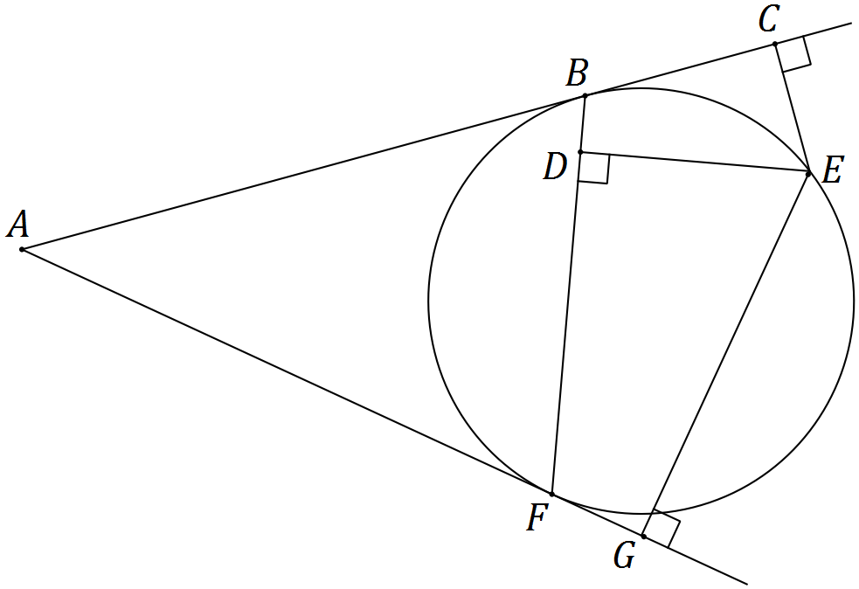

(a) Show that $ΔBCE$ and $ΔFDE$ are similar. (3 marks)

(b) Show that $DE^{2}=CE×GE$. (4 marks)